Maglev Trains Project
Name:
Institution:
Course:
Professor:
Date:

The development of superconductors has witnessed a wide range of applications, including magnetic resonance imaging (MRI), magnetic levitation, nuclear magnetic resonance, and magnetic confinement fusion reactors among others (Kim, 2019). Superconductors are materials with the ability to conduct electricity without any impedance. This ability is achieved when a certain temperature is reached; this temperature allows the material to lose all its resistance. Another characteristic of superconductors is that they have perfect diamagnetism. Perfect diamagnetism allows the superconductor to maintain a zero net magnetic field when a magnetic field is applied. Therefore, passing magnetic field through a superconducting material will cause the field to be repelled. For a superconductor to remain functional, its critical temperature and magnetic field must be maintained. At the critical temperature, the critical magnetic field should be zero, otherwise superconductivity will be destroyed.
One of the major uses of superconductors is in maglev trains. Maglev train is a system of train transportation that uses two sets of magnets, one for repulsion and another for propulsion of the train above the tracks. According to Yaghoubi (2013), this system ensures that there is zero friction, which increases efficiency, useful life of the system, and cuts maintenance costs. Maglev trains operate using the electrodynamic suspension (EDS), which uses the repulsive force of magnets to lift the train from the rail tracks. Magnets used in the system are superconductors and operate in a supercooled temperature. The system uses two magnetic fields, one from the superconducting magnet and the other is induced by the changing magnetic field as the magnet moves relative to the superconductor (Hao et al., 2018). Maglev trains can reach maximum speeds of 603km/h.
The EDS system uses the motion of the train to induce eddy currents in the tracks, which causes repulsion. The tracks have magnetic coils to create an overlapping pattern of north and south magnetic fields. Acceleration is achieved by rapidly alternating the superconducting magnets to attract the front of the train to the next coil along the track. The track is designed with magnetized coils, which repel the magnets fitted under the carriage to cause levitation. After levitation, power is supplied to the system to cause magnet fields. The electric current supplied to the coils is alternating to change the polarity of the coils. Changing polarity makes the train to be attracted forward, leading to acceleration.
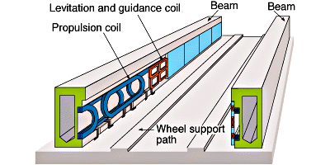
Figure 1: maglev rail design

References
Hao, L., Huang, Z., Dong, F., Qiu, D., Shen, B., & Jin, Z. (2018). Study on electrodynamic suspension system with high-temperature superconducting magnets for a high-speed maglev train. IEEE Transactions on Applied Superconductivity, 29(2), 1-5.
Kim, C. J. (2019). Applications of Superconductors. In Superconductor Levitation (pp. 213-236). Springer, Singapore.
Yaghoubi, H. (2013). The most important maglev applications. Journal of Engineering, 2013.

